**Understanding Customer behavior and market trand**

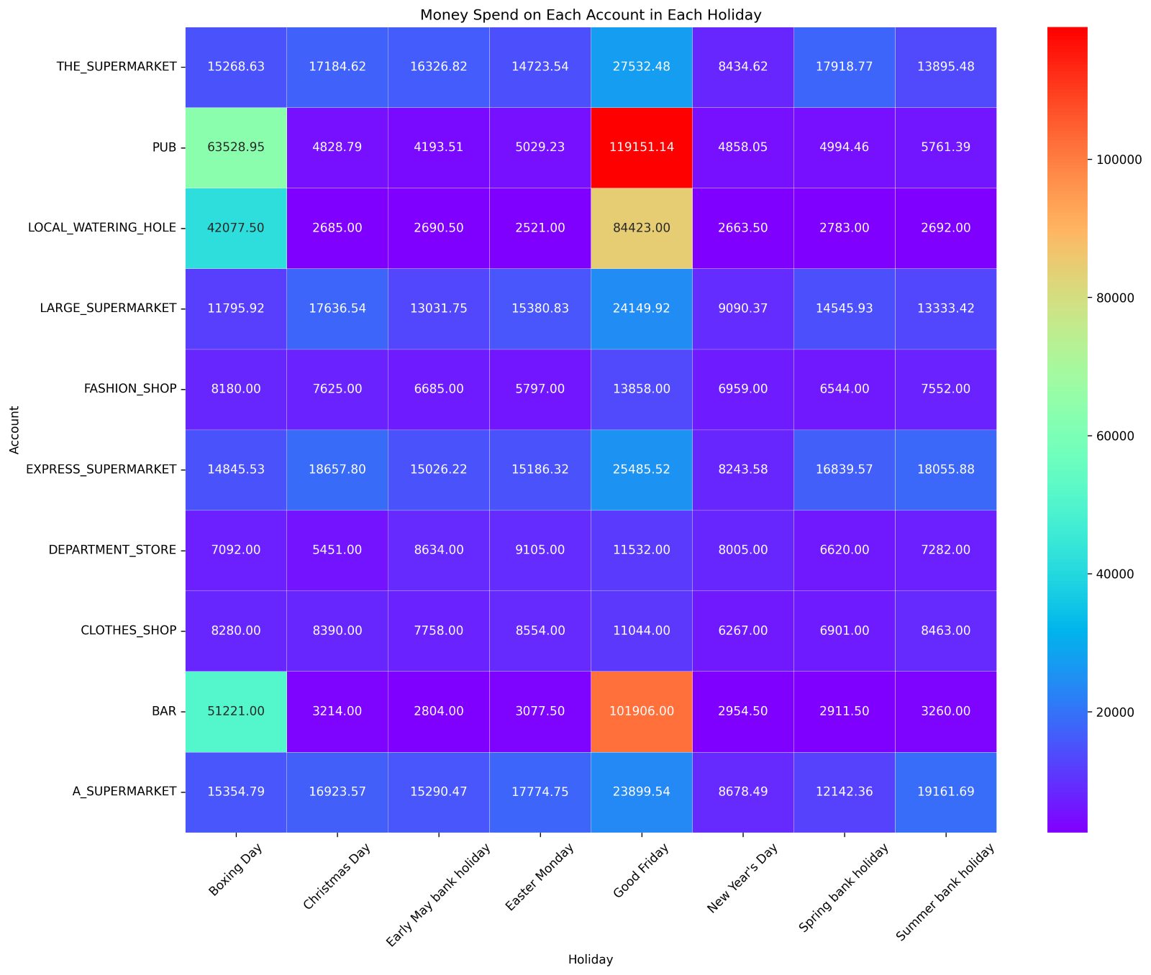

This heatmap shows the top ten businesses in each holiday, people tend to spend money on PUB and BAR on Good Friday and Boxing Day. This finding suggests that there is a cultural association between celebration and parties with alcoholic beverages.

Clearly, people allocate a portion of their expenditure toward these specific businesses. Recognizing alcohol-related spending throughout the year can make us market suitable strategies for customer preference.

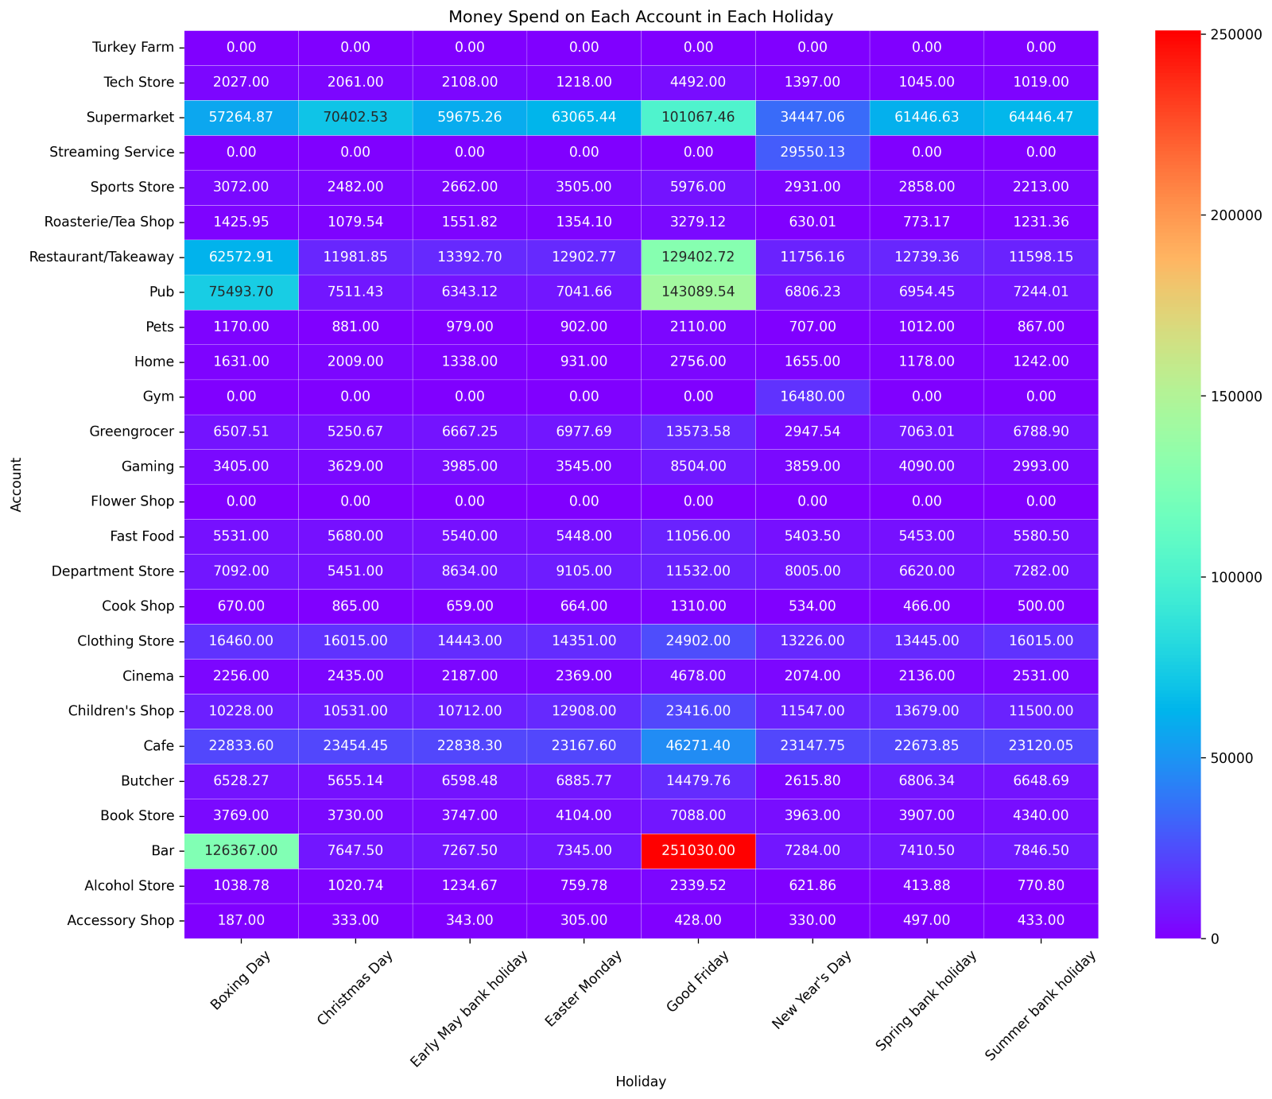

I group businesses by category. This heatmap shows all categories we had. Supermarkets are the most popular category across most holidays. This indicates a general emphasis on food and household items during these periods.

Spending in pubs and restaurants significantly increases during holidays like Boxing Day and Good Friday, so it is shown that people more focus on socializing and celebrations.

Furthermore, spending on categories like the Tech Store and Streaming Services appears less impacted by specific holidays, indicating a more consistent spending pattern throughout the year.

Lastly, no people by flower in flower shop in such holidays.

Analysis of data related to such holidays shows customer segmentation opportunities. Using this data, we can run customer-centric marketing campaigns in order to dramatically increase customer satisfaction.

In normal day, alcohol-related businesses still gain a lot of money from people in weekend followed by supermarket; however, in weekday people mostly spend money on Supermarket and Electronic.

In figure one shows the money that top 10 businesses got from people in each payment, it is clear that TECH_SHOP and ELECTRONICS related shop are higher than other with the price of products per piece more expensive. However, people rarely buy new tech products, so in overall income pub and bar revenue clearly higher because people can drink in those places as much as possible.

Clearly, most of the business income is on Friday to Sunday, related to pub and bar income because people go to pubs when tomorrow is free. So, it is unsurprised that why business get money more on Friday to Sunday.

Demi: why use sum? From Monday to Sunday in 2025 is [52, 52, 53, 52, 51, 52, 52]

Isarapon: For looking at the store to see how much money they received in total during those days. I think it's more meaningful to interpret it with average.

Both the overall transaction volume and the merchant transaction volume exhibit a similar pattern, where the transactions on Friday, Saturday, and Sunday are substantially higher compared to other days, with Friday recording the highest volume of transactions.

**Time series**

Monthly: month-end decrease, decrease and increase in several months, top 10 store

Figure 1 & 2 & 3

From Figure 1, we observe periodic fluctuations and missing data - August 22nd.

By breaking down the transactions into Figure 3 for merchant transactions and Figure 4 for personal transfers, we find that merchant transactions exhibit weekly fluctuations with a rise in December.    
Conversely, personal transfers demonstrate a downturn at the end of each month.

There are 79 stores for merchant transactions. Among them, the "FLORIST" only makes transactions on February 14th, and the "TURKEY FARM" only in December. The other 77 stores have transactions every month. "STREAMING SERVICE" and "GYM" only transact on the first of each month.

Figure 1 & 2 & 3

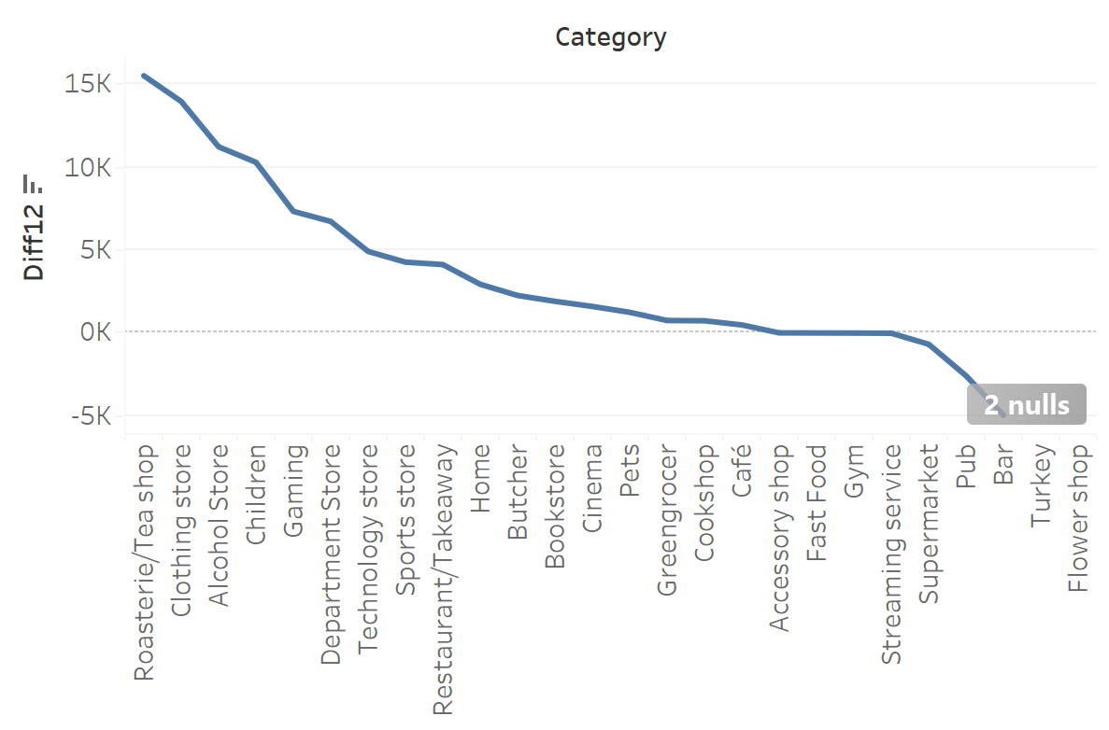

Focusing solely on merchant transactions, Figure 1 illustrates a rise in the average daily transaction amount in December, and a decrease in the same during April, July, and September.

By the merchant categories, we notice from Figure 2 that the decline in these months is primarily driven by three types of merchants: "Bar," "Pub," and "Restaurant/Takeaway." Conversely, as shown in Figure 3, the increase in December is predominantly due to categories such as "Tea Shop," "Clothing Store," "Alcohol Store," and "Children's Store" among others.